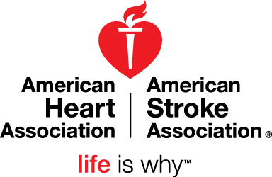

2017 HANDS-ONLY CPR FACT SHEET

WHY LEARN HANDS-ONLY CPR?
Cardiac arrest – an electrical malfunction in the heart that causes an irregular heartbeat (arrhythmia) and disrupts the flow of blood to the brain, lungs and other organs - is a leading cause of death. Each year, more than 350,000 out-of-hospital cardiac arrests occur in the United States.
- When a person has a cardiac arrest, survival depends on immediately receiving CPR from someone nearby.
- According to the American Heart Association, about 90 percent of people who suffer out-of-hospital cardiac arrests die. CPR, especially if performed immediately, can double or triple a cardiac arrest victim’s chance of survival.

BE THE DIFFERENCE FOR SOMEONE YOU LOVE
If you are called on to perform CPR in an emergency, you will most likely be trying to save the life of someone you love: a child, a spouse, a parent or a friend.
- Seventy percent of out-of-hospital cardiac arrests happen in homes.
- About 46 percent of people who experience an out-of-hospital cardiac arrest receive the immediate help that they need before professional help arrives.
- Hands-Only CPR has been shown to be as effective as conventional CPR for cardiac arrest at home, at work or in public spaces.

MUSIC CAN SAVE LIVES
- Hands-Only CPR has just two easy steps, performed in this order: (1) Call 9-1-1 if you see a teen or adult suddenly collapse; and (2) Push hard and fast in the center of the chest to the beat of a familiar song that has 100 to 120 beats per minute. Song examples include “Stayin’ Alive” by the Bee Gees, “Crazy in Love” by Beyoncé featuring Jay-Z, “Hips Don’t Lie” by Shakira” or “Walk the Line” by Johnny Cash.
- People feel more confident performing Hands-Only CPR and are more likely to remember the correct rate when trained to the beat of a familiar song.
- When performing CPR, you should push on the chest at a rate of 100 to 120 compressions per minute, which corresponds to the beat of the song examples above.

TAKE 90 SECONDS TO LEARN HOW TO SAVE A LIFE
Watch the 90-second demo video. Visit heart.org/handsonlycpr to watch the Hands-Only CPR instructional video and share it with the important people in your life. Hands-Only CPR is a natural introduction to CPR, and the AHA encourages everyone to learn conventional CPR as a next step. You can find a CPR class near you at heart.org/findacourse and/or purchase a CPR Anytime® Kit at shopheart.org/cpr-anytime.

NOTE: The AHA still recommends CPR with compressions and breaths for infants and children and victims of drowning, drug overdose, or people who collapse due to breathing problems.

March 2017

