Illinois Heart Rescue Pre and Post Test

- What is the proper rate of chest compressions to help save a collapsed adult victim?

- 50 per minute

- 75 per minute

- 100 per minute

- 200 per minute

- What is the adequate depth for chest compression?

- 1 inch

- 2 inches

- ½ inch

- 4 inches

- What is the name of the device in the image?
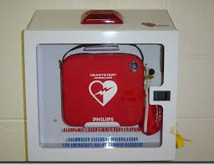

- Alternative battery system (ABS)

- Automatic external defibrillator (AED)

- Automatic ventilation device (AVD)

- Emergency compression machine (ACM)

- What does this device do?

- Delivers an electric shock to re-circuit the electrical impulse of the heart

- Opens up clogged arteries in the heart

- Performs chest compressions

- Provides an ultrasound image of the heart

- How easy is this device to use?

- EASY: Open the case, turn it on and follow the automated instructions

- MEDIUM: Only those certified in CPR should use it

- HARD: Only trained medical professionals should use it

- What is the best thing to do if you see someone collapse and they do not respond to their name of if you shake them?

- Call 911 and wait for the paramedics to arrive

- Call 911 and start doing mouth-to-mouth ventilations

- Call 911 and start doing chest compressions

- Call 911, start doing hands only CPR and send someone for an AED

