CARES logo_red

CARES EMS User Guide

**INDEX**

**CARES Website ..……...……………………………………………………………………………..….……….….. 3**

**The Dashboard ..…………………………………………………………………………….………………………… 4**

**Changing Your Password ...……………………………………………………………………...................... 5**

**Adding a New Case …..………………………………………………………………………………………………. 6**

**CARES Search ………………………………………………………………………………..……………………..… 9**

**Exporting Data ……………………………………………………………………………………………………...... 9**

**REPORTS**

**Utstein ………….…………………………………………………………………………………………..… 10**

**Call Times ………………………………………………………………………………………………..….. 13**

**EMS CAD Times/First Responder CAD Times …..…………………………..………………… 14**

**Demographics ..………………………………………………………………………………………….… 15**

**Mass Communication/Listserv …..……………………………………………………………………………. 16**

**OPTIONAL MODULES**

**Dispatcher-Assisted CPR (DACPR) Module …..……………………………………………….. 17**

**CARES WEBSITE:**

**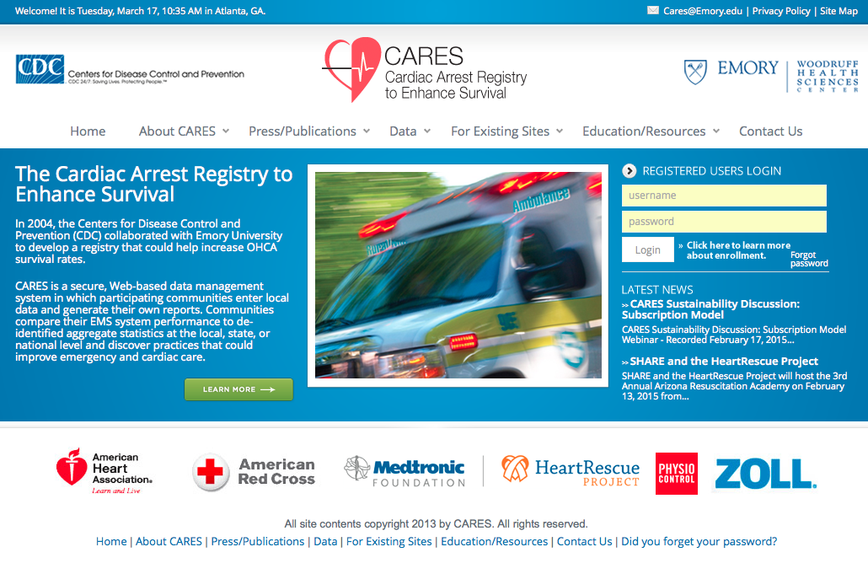**

The CARES website hosts a number of useful documents for program stakeholders. A summary of the resources available under each tab is found below:

• **About CARES** – program overview, latest news, community/state map, enrollment information.

• **Press/Publications** - publications, newsletters, press releases about CARES.

• **Data**- data dictionary, legacy reports, XML information, data sharing policies.

• **For Existing Sites** - letters of support, FAQ sheets, user guides.

• **Education/Resources** – supplemental module information, links to training opportunities.

• **Contact** - contact information for CARES staff and state coordinators.

If you’ve forgotten your CARES password, please click on the “**Forgot password**” link below the log-in box. You’ll be prompted to answer your unique password question, and a new password will be e-mailed to you.

**CARES CASE DEFINITION:**

A CARES case is a non-traumatic out-of-hospital cardiac arrest event where resuscitation is attempted by a 911 responder (CPR and/or defibrillation). This includes patients that received an AED shock by a bystander prior to the arrival of 911 responders. When selecting a Service Date range of interest, please note: CARES collected only arrests of presumed cardiac etiology from 2005-2012. In 2013, CARES expanded to include all non-traumatic arrests.

This User Guide includes a number of data definitions. For additional examples, please refer to the CARES Data Dictionary, available at <https://mycares.net/sitepages/uploads/2013/04/Data-Dictionary-2013.pdf>.

**THE DASHBOARD:**

Below is the screen you see immediately after logging in. This initial screen is your Dashboard and has several different tabs. Please keep in mind that all data on the Dashboard is updated in real-time as data is entered, updated, or deleted.

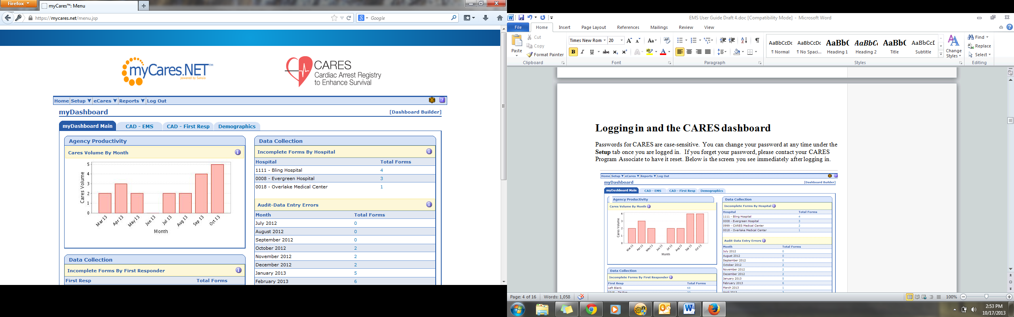The **Agency Productivity** box shows call volume over the past 8 months. **Incomplete Forms byHospital** shows all forms that have not been completed by local hospital contacts. The **Audit-Data Entry Errors** box displays any records being flagged for auditing issues. If you click on the number next to the Month or Hospital the site will direct you to the respective records. Click the pen and paper icon to edit the record and ‘Save’ your updates.

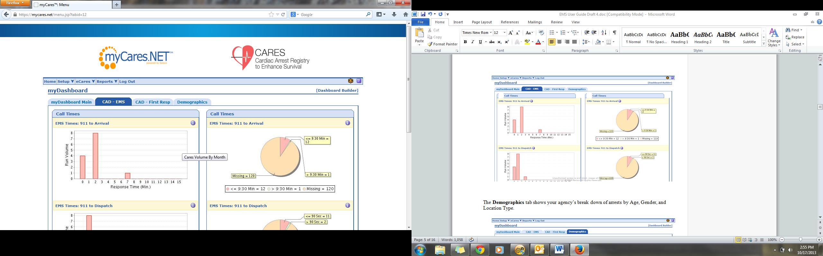The 2nd and 3rd Dashboard tabs, **CAD-EMS** and **CAD-First Responder**, display CAD time intervals for local response times in bar graph and pie chart format, if you enter this supplemental data into CARES.

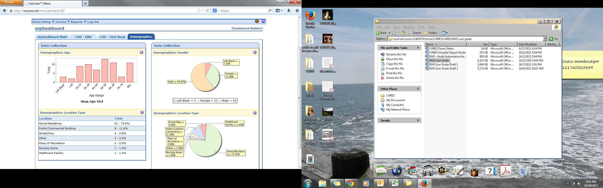The **Demographics** tab displays your agency’s arrests by Age, Gender, and Location Type.

**CHANGING YOUR PASSWORD:**

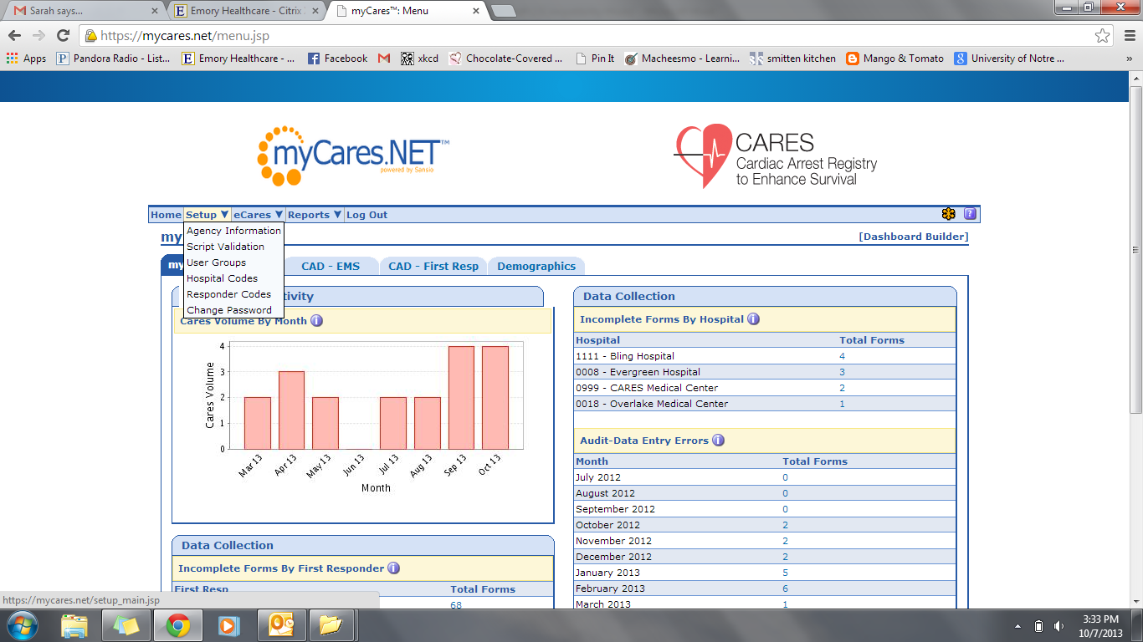Passwords for CARES are case-sensitive. You can change your password at any time under the **Setup** tab once you are logged in. If you’ve forgotten your CARES password, please click on the “Forgot password” link below the log-in box on the homepage. You’ll be prompted to answer your unique password question, and a new password will be e-mailed to you.

**ADDING A NEW CASE:**

If you are doing direct data entry, clicking **Add New** from the **eCares** tab will bring you to a blank CARES form. Required elements are in a grey background (i.e. questions 1-11) and supplemental elements are in a blue background (i.e. question 12). The CARES case definition is as follows:

“An out-of-hospital cardiac arrest of non-traumatic etiology where resuscitation is attempted by a 911 responder (CPR and/or defibrillation). This would also include patients that received an AED shock by a bystander prior to the arrival of 911 responders.”

All patients meeting this case definition must be entered into CARES.

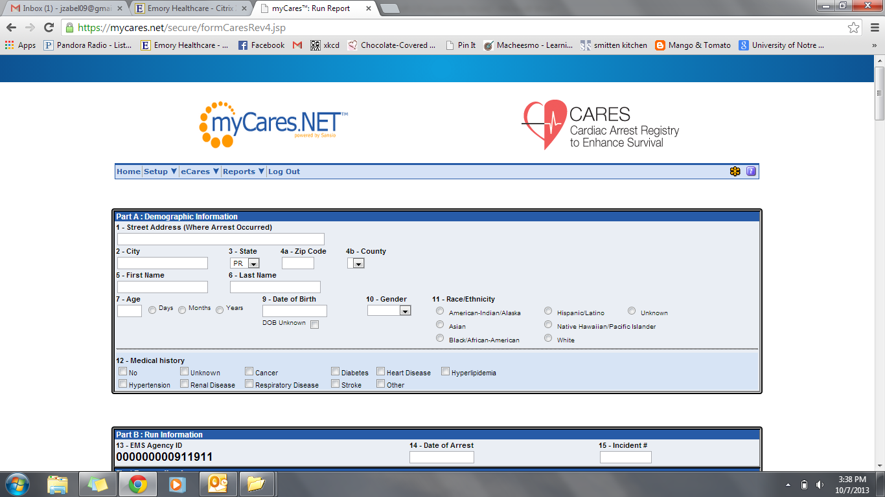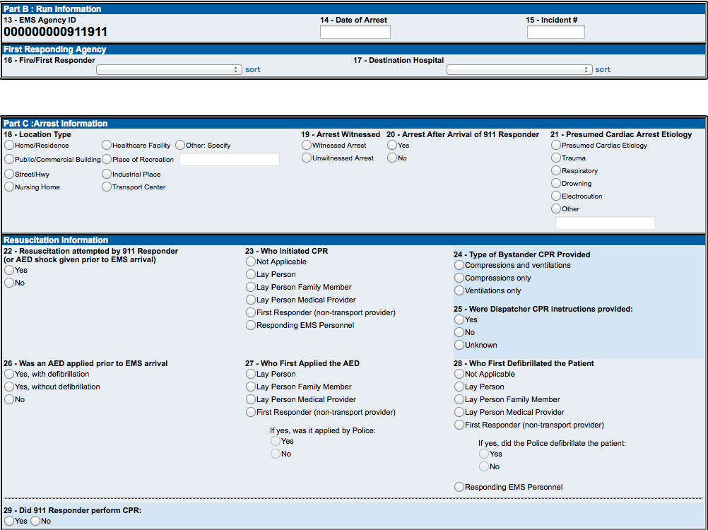

Question 33 is the last required question. When you select “Ongoing Resuscitation in ED” the hospital will automatically be notified that a patient outcome is required if the record meets the CARES case definition. If End of Event is “Pronounced in the ED”, the record is not routed to the hospital, 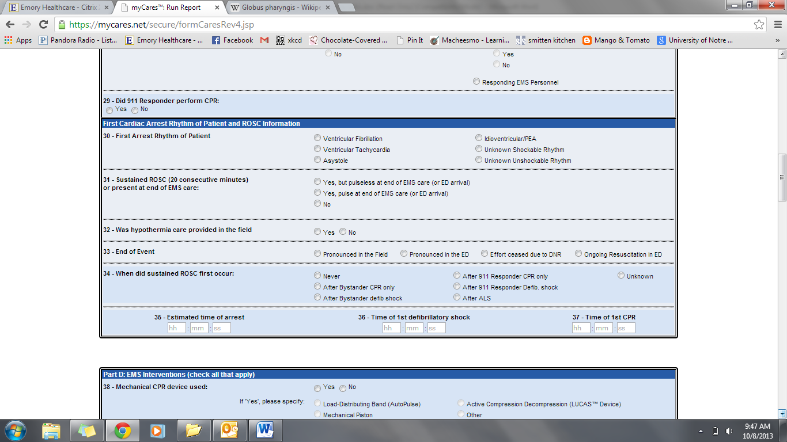decreasing the data entry burden for hospital personnel.

**General Comments Box**

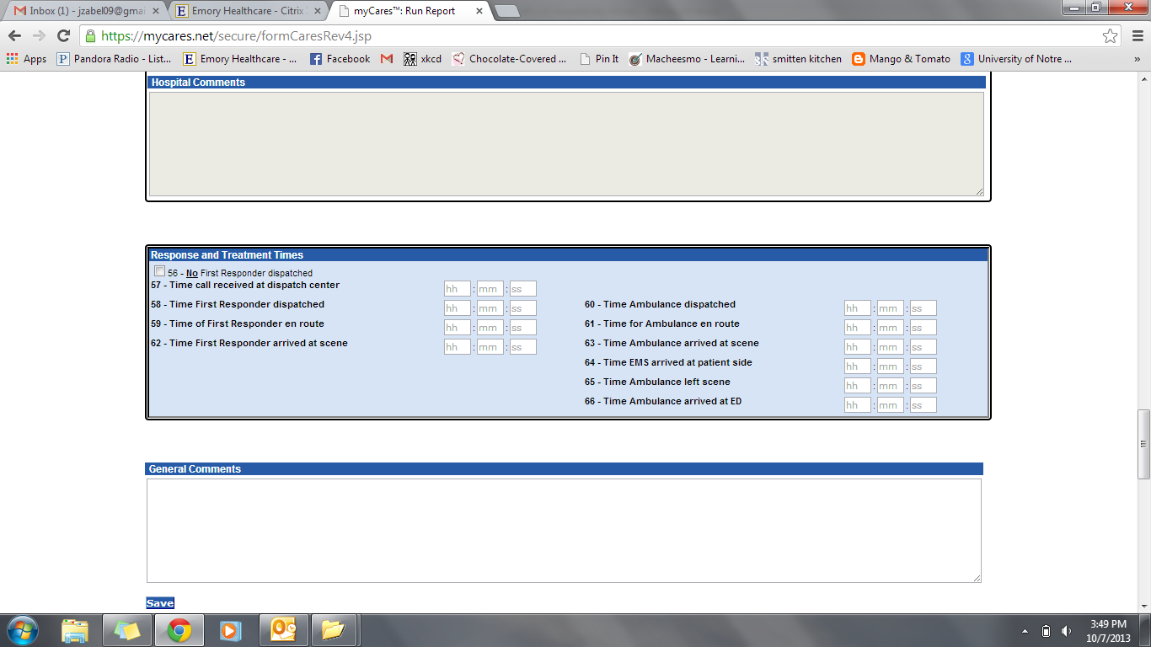At the bottom of the form is a General Comments box for EMS agency users. Please enter any comments or additional information you think CARES staff or hospital contacts should know about the patient or event. Entering comments is also important if you enter data that seems contradictory, but is correct (i.e. patient in VFib, but not defibrillated), so that CARES staff will manually override the audit flag.

**Saving the Form**

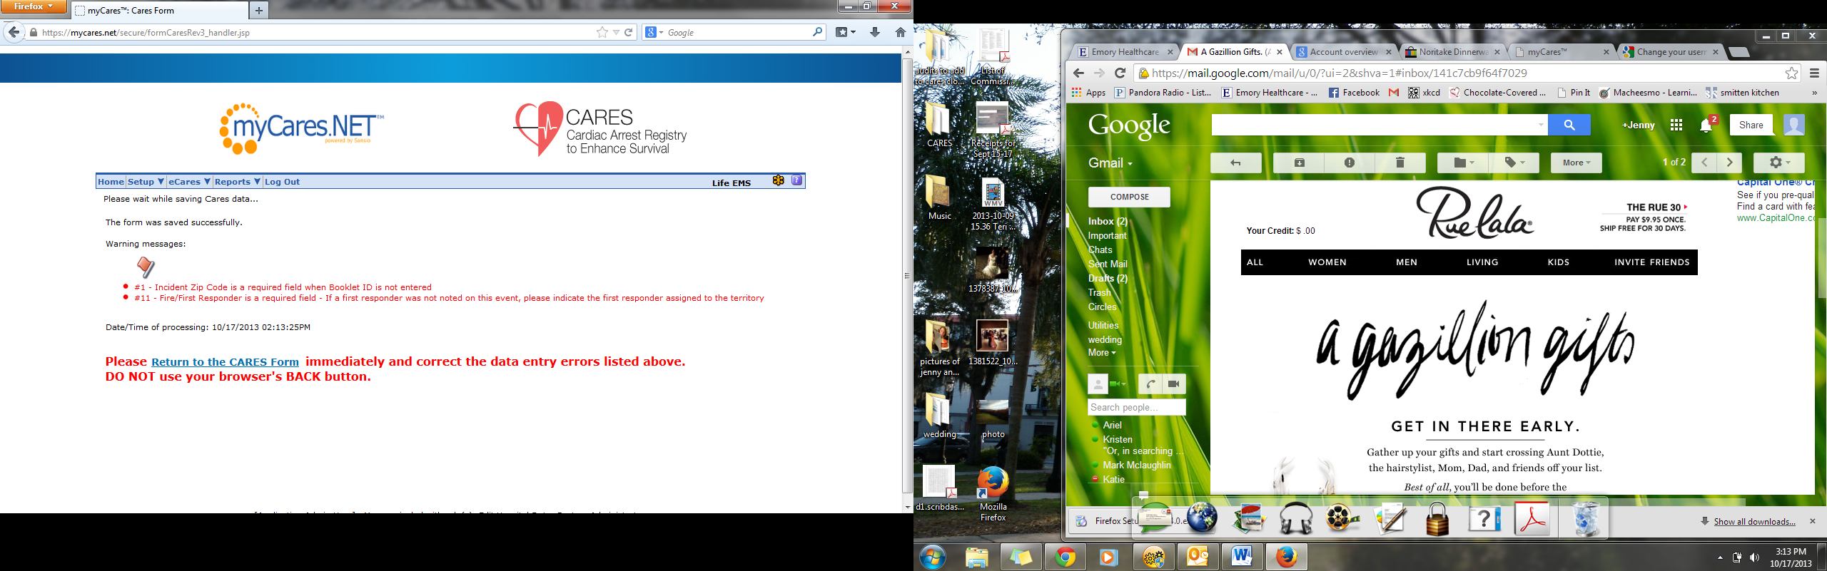When you click “Save”, an automated audit algorithm is run on the record, checking for blank fields and potentially conflicting information. The associated audit flags will be listed on the Save page in red. Please click on the “Return to the CARES Form” link and address these audit flags. Do NOT use your browser’s Back button to return to the form.

The fields that require attention are listed at the top of the page and highlighted in red. Click “Save” when problematic fields have been updated in the form.

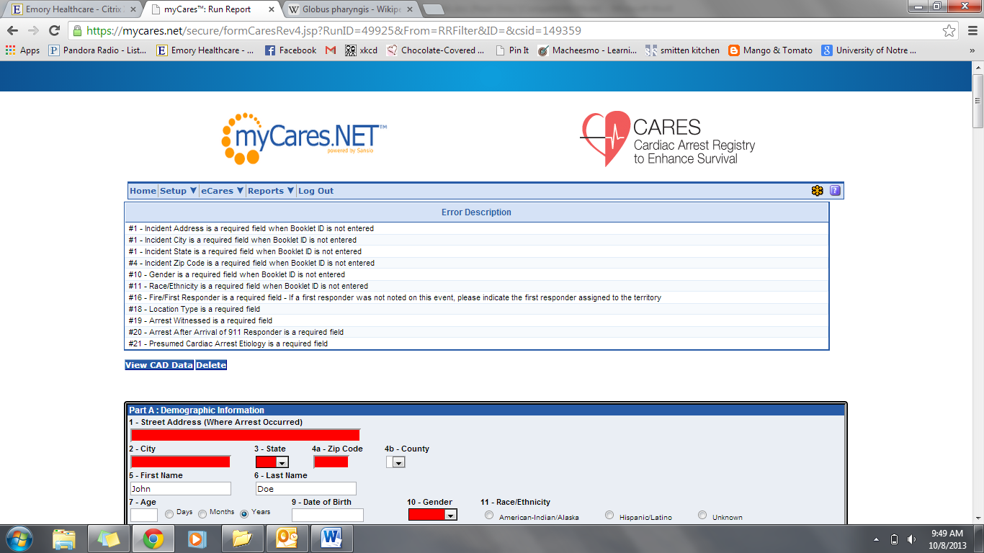

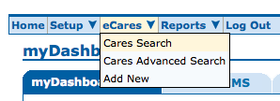**CONDUCTING A SEARCH:**

The **CARES Search** page is limited to the required data elements, while the **CARES Advanced Search** page includes the supplemental data elements. You can search by any data element(s) on the CARES form.

The **Filter** pull-down menu in the upper left-hand corner includes the following search filters: Presumed Cardiac CARES Cases, Non-Traumatic CARES Cases, Utstein Arrests.

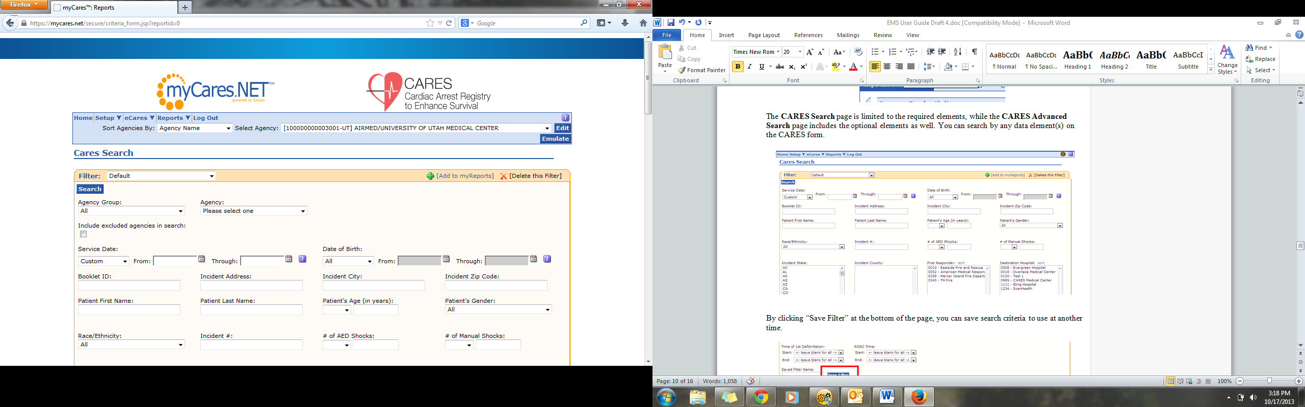

By clicking “**Save Filter**” at the bottom of the page, you can save search criteria to use at another time.

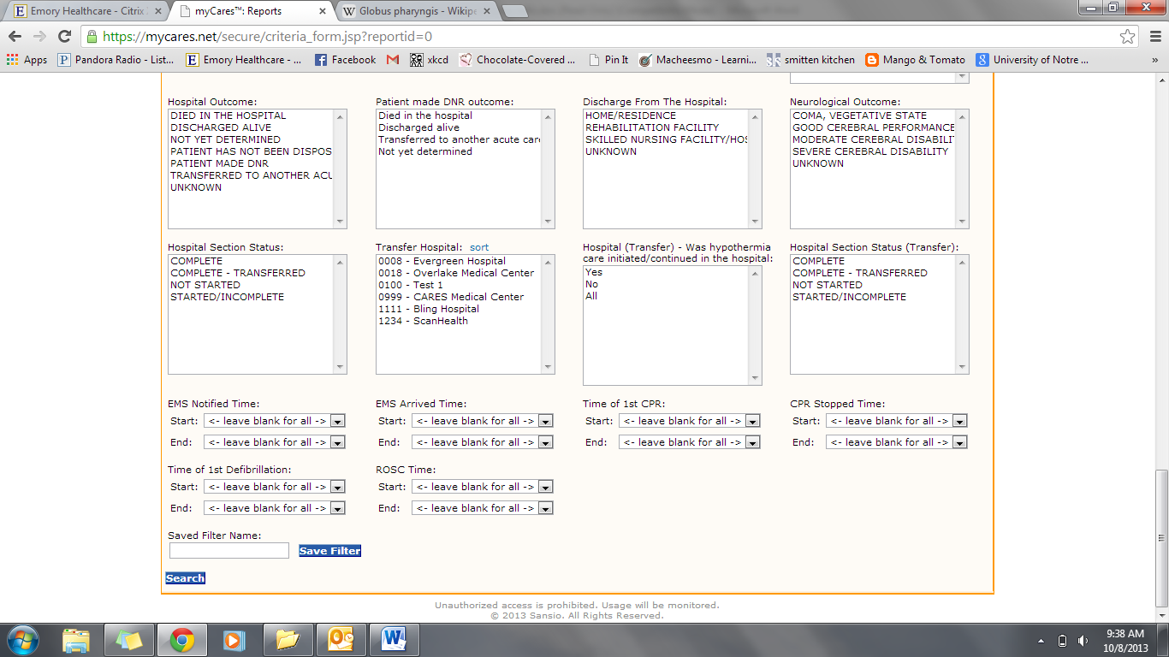

**EXPORTING DATA:**

Search results can be exported into Microsoft Excel for further review and analysis. On the search results page, in the upper right-hand corner is a “Send results to” drop down menu. Click the drop down arrow and select “**Excel export of data**” or “**Excel export of data with optional elements**”. Click “Go”. Please be sure your browser’s pop-up blocker is turned off or hold down the “Ctrl” key while going through the above steps until the Excel window opens.

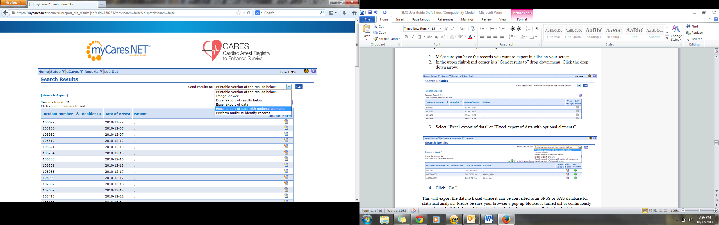

**REPORTS:**

CARES users have 24/7 access to a number of reports, which can be found on the **Reports** drop down menu.

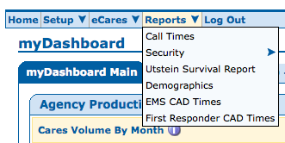**For further interpretation of the CARES reports, users may access the full Reports User Guide and EMS Reports Webinar via the CARES website at:** [**https://mycares.net/sitepages/reports.jsp**](https://mycares.net/sitepages/reports.jsp)**.**

The **Utstein** **Survival Report** is the most commonly used report. Utstein is an internationally agreed upon cardiac arrest metric that considers all bystander-witnessed arrests that present in a shockable rhythm.[[1]](#footnote-1) To generate this report:

1. Enter the **Service Date** range of interest. Reports using recent data are not completely audited and therefore may be incomplete. Data by calendar year is not finalized until April 1st of the following year. For example, reports including data from 2014 would not be considered final until April 1, 2015.
2. Select the **Data Scope** of interest. “My Data” will generate a report using your EMS Agency’s data, while “National Data” will generate a benchmarking report using the national dataset.
3. Select the **Etiology** of arrest, Presumed Cardiac or Non-Traumatic.
4. Click “**Generate Report**”.

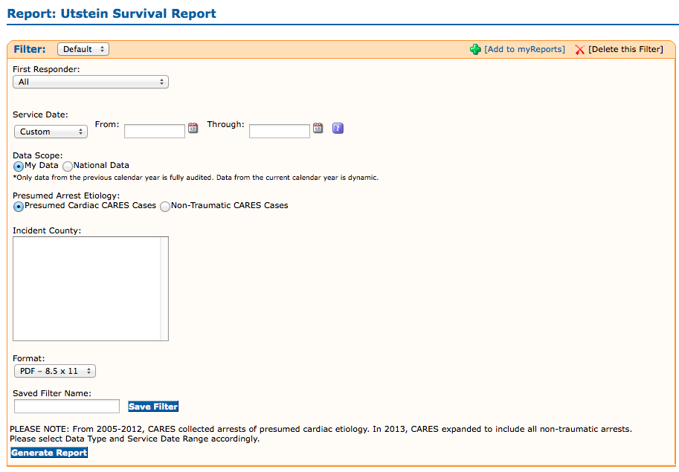The Utstein Report can also be filtered by local First Responders or Incident Counties using the corresponding pull-down menu or selection box.

In the upper right-hand corner of the Utstein Report, you will see a box listing a number of survival rates.

* **Overall**: Includes all CARES cases.
* **Bystander Wit’d**: Includes all bystander witnessed arrests (those found on page 1 of the report).
* **Unwitnessed**: Includes all unwitnessed arrests (those found on page 2 of the report).
* **Utstein**: Witnessed by bystander and found in shockable rhythm.
* **Utstein Bystander**: Witnessed by bystander, found in shockable rhythm, and received some bystander intervention (CPR and/or AED application).

Below, you’ll find a box that provides rates of critical **Bystander Interventions**, including CPR and AED use. These two rates *exclude* 911 Responder Witnessed and Nursing Home/Healthcare Facility arrests.

The Utstein Report follows a flow diagram format, categorizing arrests by witness status, initial rhythm, and patient outcome. **Bystander Witnessed** arrests are found on page 1.

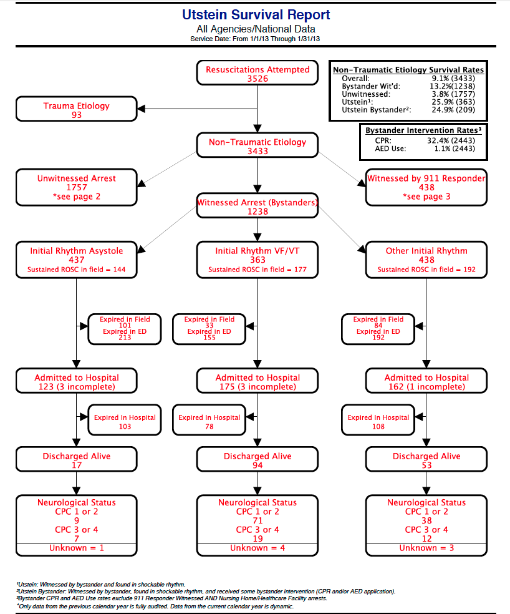

**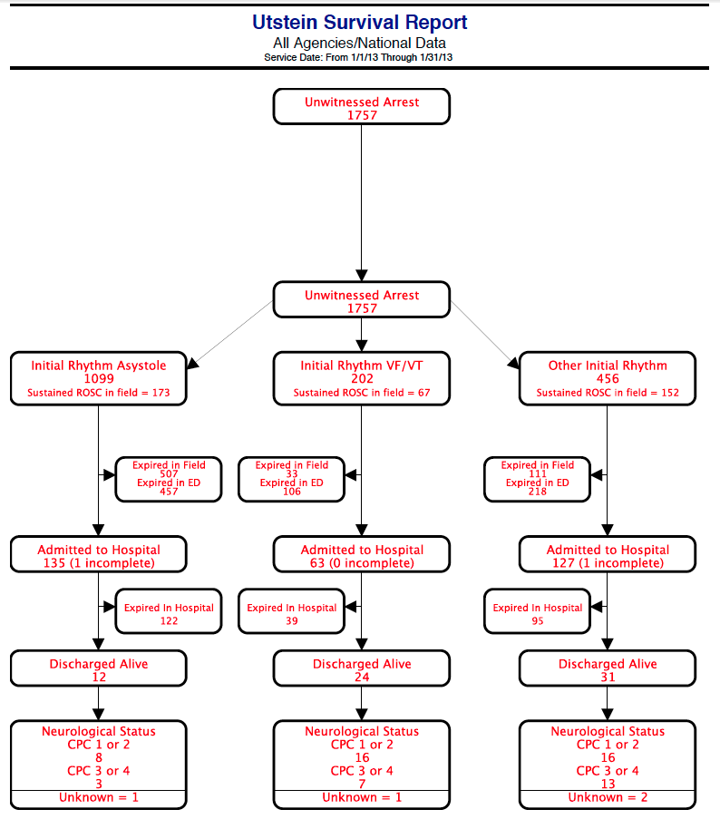Unwitnessed** arrests are found on page 2.

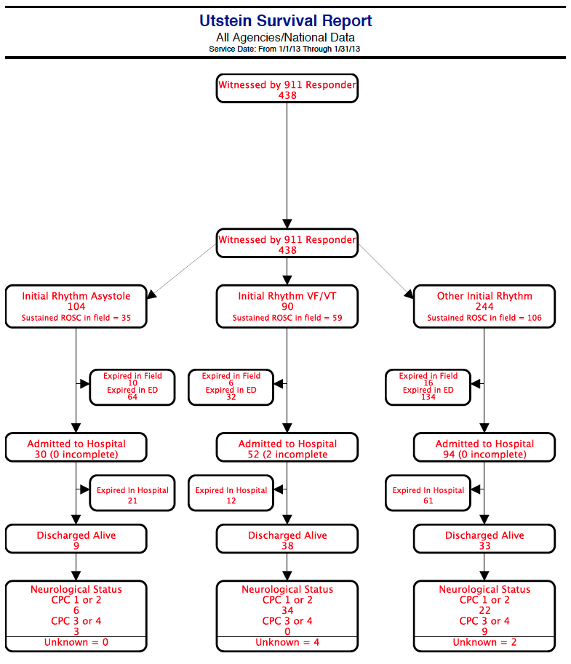

**911 Responder Witnessed** arrests are found on page 3.

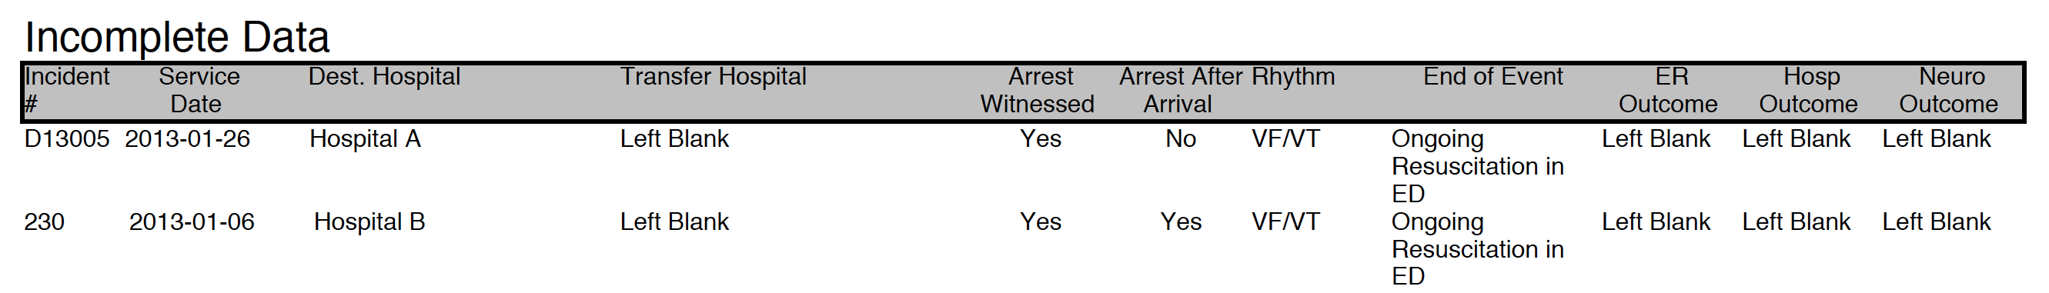Page 4 lists any records that have an outstanding hospital outcome. The CARES **Call Times Report** shows the number of runs in a given 30 second response time interval, if your agency enters this supplemental information into CARES. Enter the Service Date range of interest and select the two times you wish to analyze from the Times pull-down menus. Click “Generate Report”.

A number of filters can be applied to this report, using the Filter pull-down menu in the upper left-hand corner (Presumed Cardiac CARES Cases, Non-Traumatic CARES Cases, Utstein Arrests) or First Responder pull-down menu.

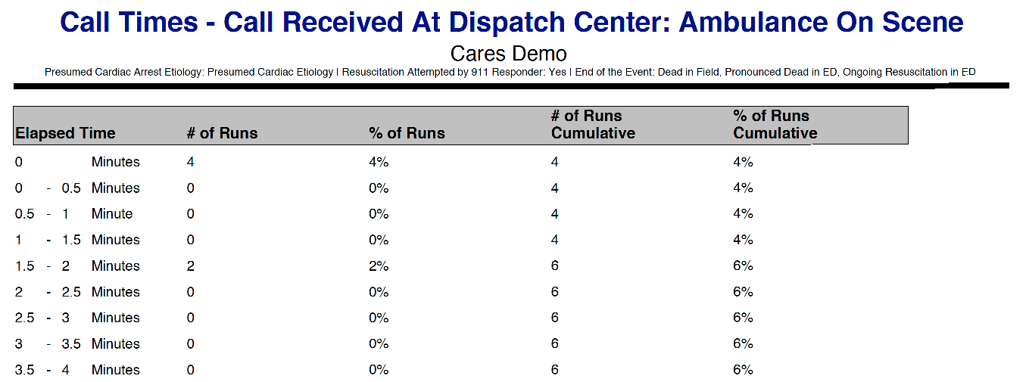

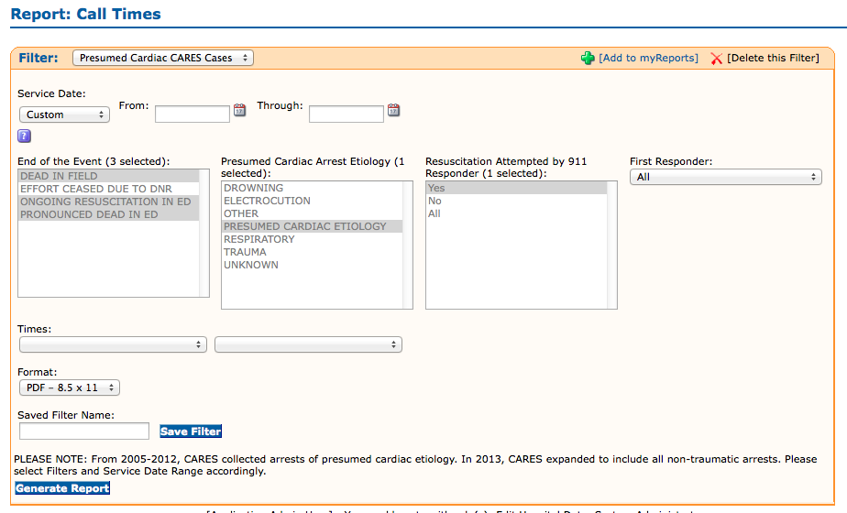

The **EMS and First Responder CAD Times** **Reports** show CAD time intervals in bar graph and pie chart format, if your agency enters this supplemental information into CARES. The SetUp page includes 2 Data Scope options: My Data will generate a report with your agency’s data, while National Data will generate a benchmarking report using the national CARES dataset. Both report setup pages also include the Filter pull-down menu in the upper left-hand corner, allowing you to filter the report by Presumed Cardiac CARES Cases, Non-Traumatic CARES Case, or Utstein Arrests. The First Responder CAD Times Report can also be filtered by your local First Responders. After selecting the report criteria, enter the Service Date range of interest, and click “Generate Report”.

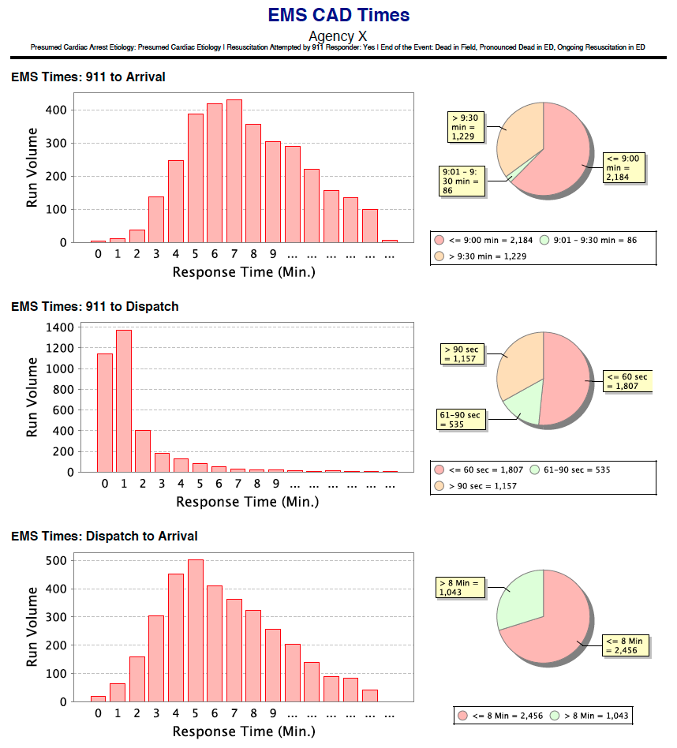

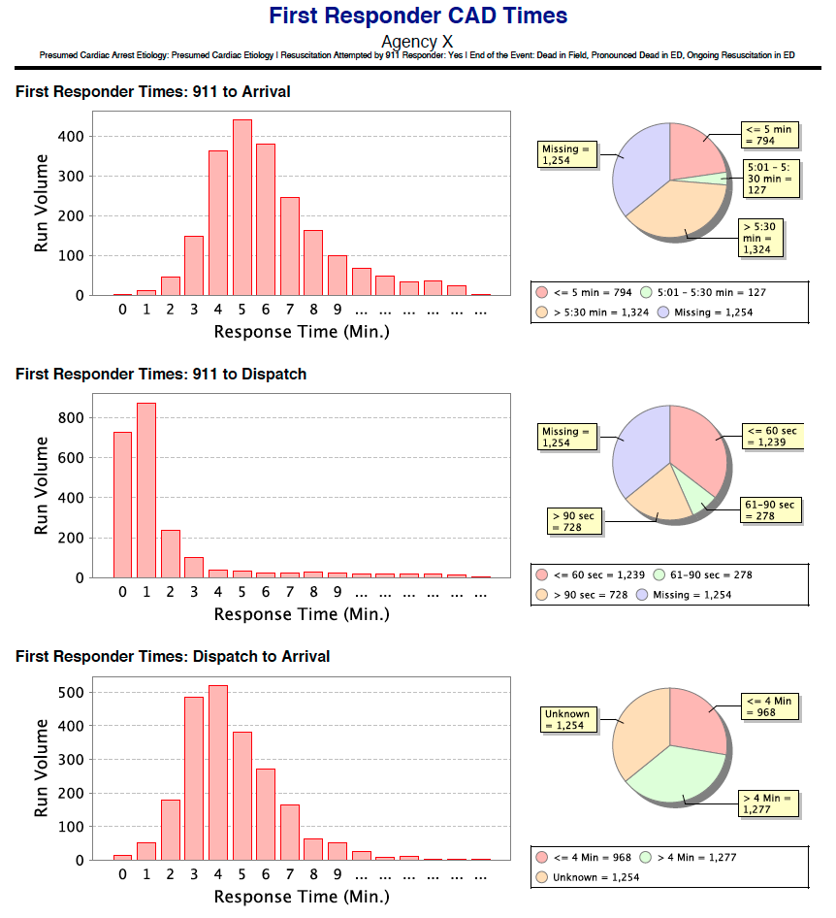The **Demographics** **Report** generates the same information as the Demographics Dashboard tab, but allows you to select a Service Date range of interest. A number of filters can be applied to this report, using the Filter pull-down menu in the upper left-hand corner (Presumed Cardiac CARES Cases, Non-Traumatic CARES Cases, Utstein Arrests).

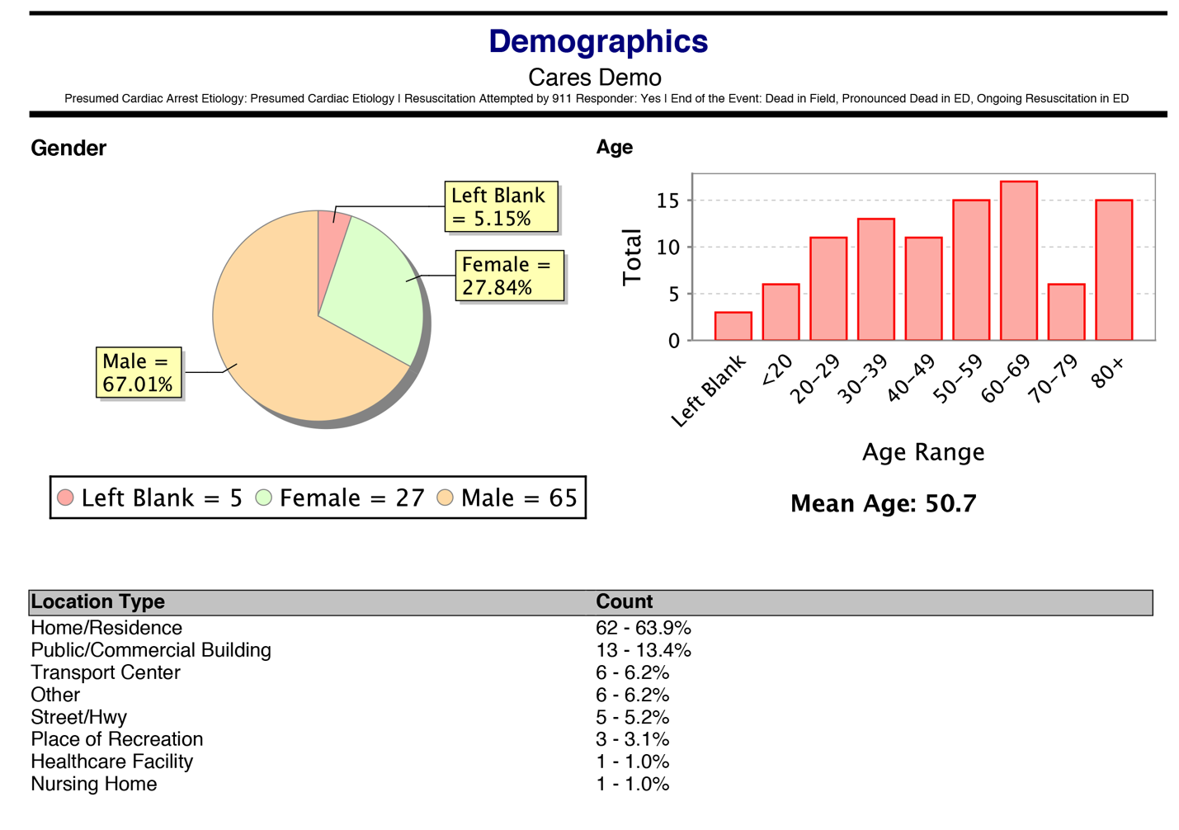

**MASS COMMUNICATION:**

Occasionally, CARES will send updates to our end users and stakeholders. These messages may include information about software upgrades and changes, training and education opportunities, or include documents such as our quarterly newsletter. You will receive these messages via e-mail, and they will also be accessible in your CARES Message Center upon log-in.

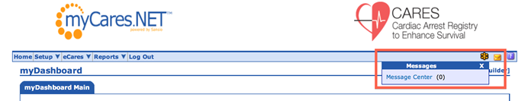Once you enter the site, a blinking, yellow envelope will indicate a new message in your inbox. You may access your Message Center at the top right-hand corner of the page.

High Priority messages will require your acknowledgment before navigating away from the page by checking the box and choosing “Save and Close”.

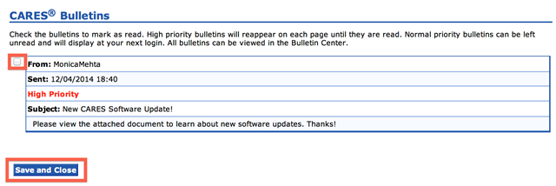

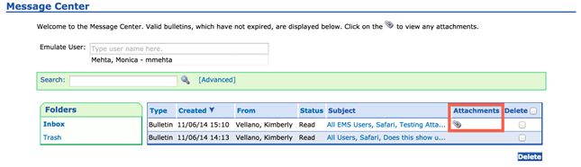You will be able to save any attachments that are included in the message for future reference by accessing your Message Center inbox and clicking on the paper clip icon under the “Attachments” column.

**DISPATCHER-ASSISTED CARDIOPULMONARY RESUSCITATION (DACPR) MODULE GUIDE:**

Please contact your CARES representative to request that the DACPR module be activated for your agency. To enter data, log in to the CARES website with your unique username and password.

Entering DACPR Data As An EMS Agency User

Once the module has been activated, the DACPR Module form is accessed by clicking on “Add New” under the eCares tab. If the EMS Agency enters data into CARES via the upload method, click on “CARES Search” to select a date range of records needing the Dispatch section manually completed. Please see the Searching section on the next page for additional information.



The user will see the CARES EMS data entry form first followed by the additional DACPR data entry section. Please refer to the CARES DACPR Data Dictionary for data definitions and coding examples. After you have completed the form, click the Save Dispatch button at the end of the Module section.

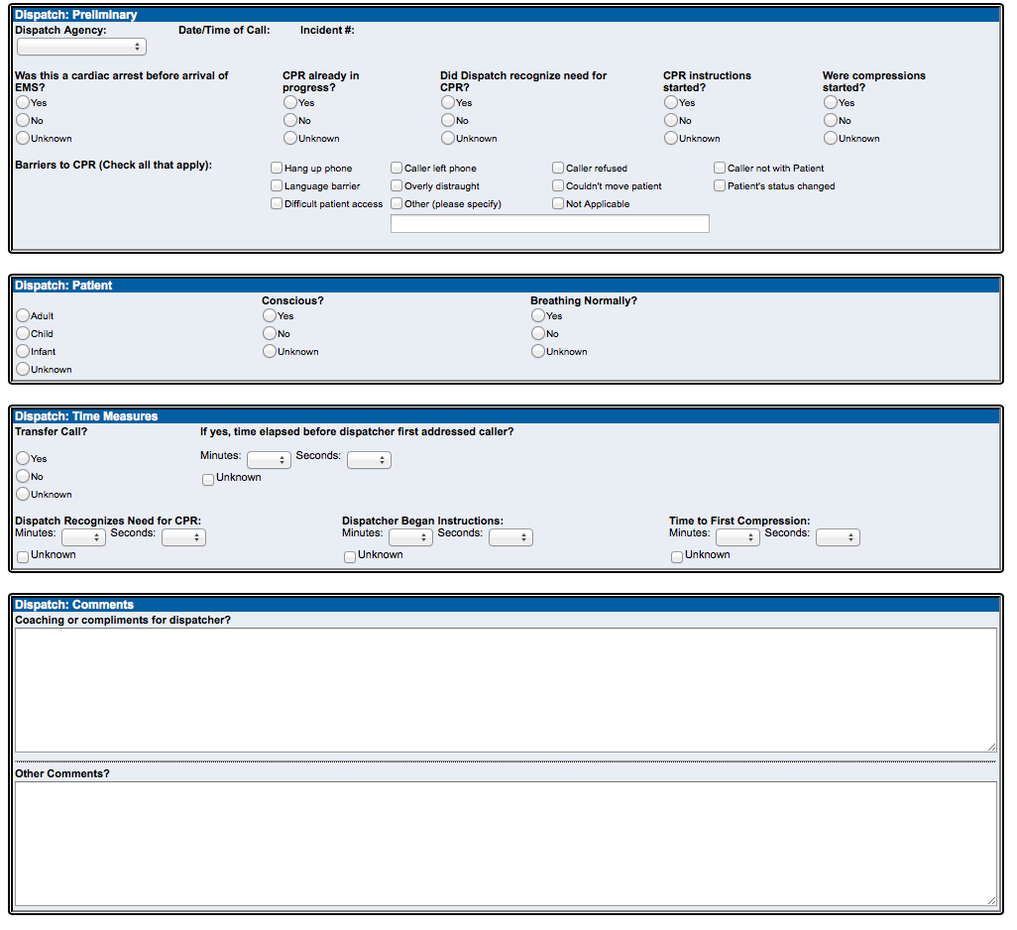

DACPR User Setup

Any CARES agency user that has System Administrator privileges may enter dispatch data for this module. If an external contact at a dispatch center or organization will be entering only DACPR data for a single EMS agency, your CARES representative can set up a “Dispatch Only” user account for them. Please contact your CARES representative to assign a “Dispatch Multi-Agency User” account to a contact entering dispatch data for multiple EMS agencies.

Lastly, if a new dispatch agency needs to be added to the “Dispatch Agency” pull-down menu, please contact your CARES representative so that they may customize your choices for this field.

Entering Data As A Dispatch Multi-Agency User

Once a multi-agency user logs in to the CARES website, they can access their agency list under the main page pull-down menu to select the agency they are entering DACPR data for and then click Emulate.

Once the agency is emulated, the multi-agency user can access records using the CARES Search page and then click on the pen/paper icon to edit each record as necessary. Please refer to the next section for details about searching for existing records.

Searching and Exporting Data

This module’s data can be accessed through the CARES Search page. The search page is found under the eCARES tab in the blue header bar. The user may search by Service Date range, Incident #, or other applicable CARES fields. Once a date range has been selected, click Search at the top left-hand side of the page.

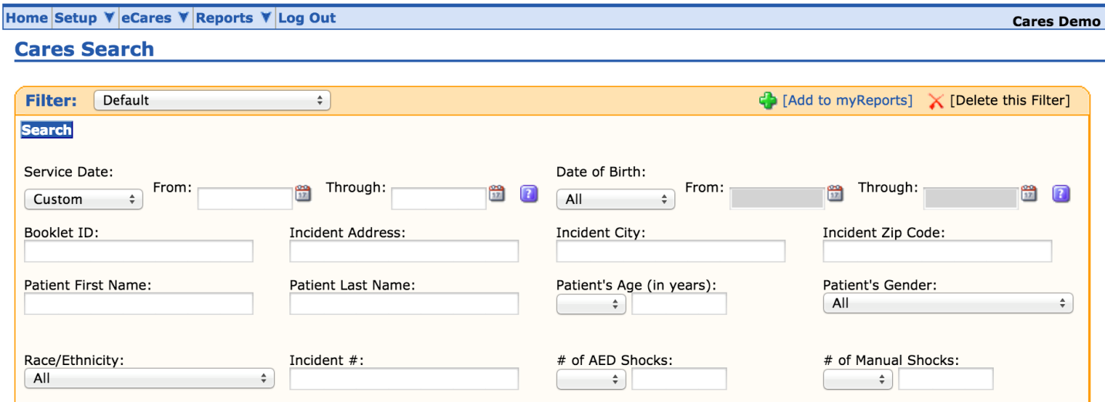

In the search results, the pencil/paper icon allows the user to edit an existing CARES form, while the green plus sign symbol in the “Add Dispatch” column indicates no DACPR data has been entered for that specific record. DACPR data is exportable into Microsoft Excel. Select “Excel export of dispatch data” from the “Send results to” pull-down menu and click Go. Please ensure that your browser’s pop-up blocker is turned off.

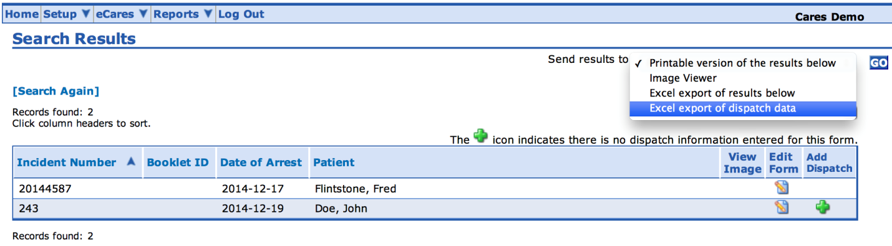

1. *Resuscitation*. 2014 Nov 25. pii: S0300-9572(14)00811-9. doi: 10.1016/j.resuscitation.2014.11.002. [Epub ahead of print] [↑](#footnote-ref-1)