

CARES Hospital User Guide

**INDEX**

**CARES Website……………………………......…………………………………………………………………..…. 3**

**Patient Outcome Data Entry………………………………………………………………………………………. 4**

**Changing Your Password………………………………………………………….………………………………. 6**

**Multi-Hospital Users………………………………………………………………………………………………… 6**

**Difficulty Locating Patients..……………………………………………………………………………………… 6**

**CARES Search and Data Export..…………………………………………………………….…………………. 7**

**Hospital Report…………………………………………………………………………………..…………………... 8**

**Mass Communication/Listserv …..……………………………………………………………………………. 10**

**OPTIONAL MODULES**

**Targeted Temperature Management (TTM) Module …..…..……………………………….. 11**

**CARES WEBSITE:**

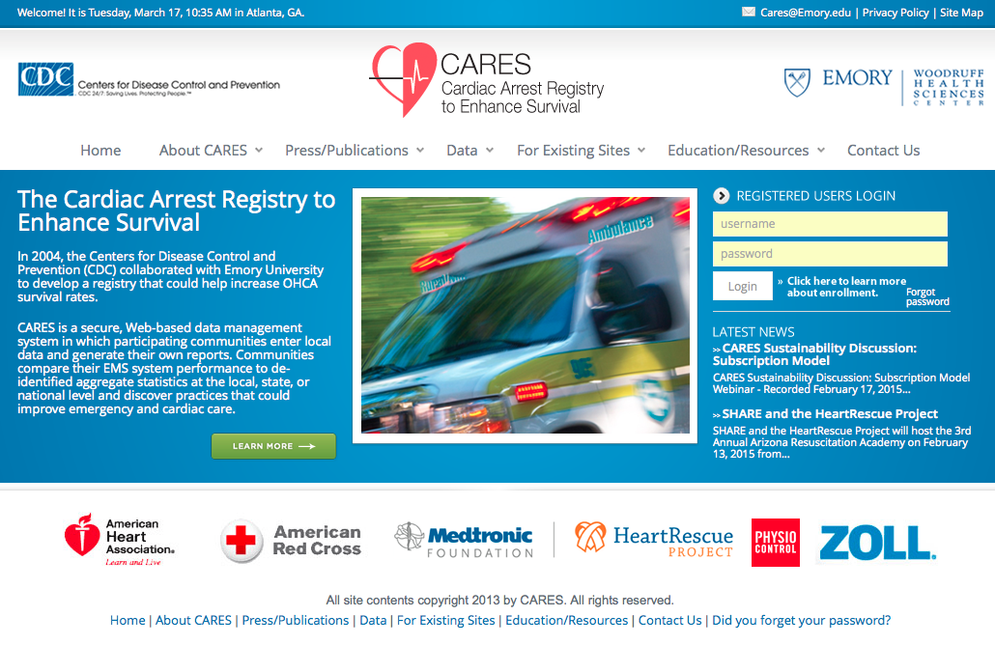

The CARES website hosts a number of useful documents for program stakeholders. A summary of the resources available under each tab is found below:

• **About CARES** – program overview, latest news, community/state map, enrollment information.

• **Press/Publications** - publications, newsletters, press releases about CARES.

• **Data**- data dictionary, legacy reports, XML information, data sharing policies.

• **For Existing Sites** - letters of support, FAQ sheets, user guides.

• **Education/Resources** – supplemental module information, links to training opportunities.

• **Contact** - contact information for CARES staff and state coordinators.

If you’ve forgotten your CARES password, please click on the “**Forgot password**” link below the login box. You’ll be prompted to answer your unique password question, and a new password will be e-mailed to you.

**CARES CASE DEFINITION:**

A CARES case is a non-traumatic out-of-hospital cardiac arrest event where resuscitation is attempted by a 911 responder (CPR and/or defibrillation). This includes patients that received an AED shock by a bystander prior to the arrival of 911 responders. When selecting a Service Date range of interest, please note: CARES only collected arrests of presumed cardiac etiology from 2005-2012. In 2013, CARES expanded to include all non-traumatic arrests.

This User Guide includes a number of data definitions. For additional examples, please refer to the CARES Data Dictionary, available at <https://mycares.net/sitepages/uploads/2013/04/Data-Dictionary-2013.pdf>.

**PATIENT OUTCOME DATA ENTRY:**

CARES sends an automated e-mail when a patient is transported to your hospital, requiring a final outcome to be entered. Depending on your facility’s call volume, please login biweekly or monthly to complete data entry. Go to the CARES homepage (<https://mycares.net>) and login using the username and *case-sensitive* password that were provided to you by CARES staff.

Once you have logged in, your Dashboard will appear. Patients that have outstanding hospital outcomes will be listed under the blue header bar. To enter data for a patient, click on the Pen and Paper icon on the right side of the screen.

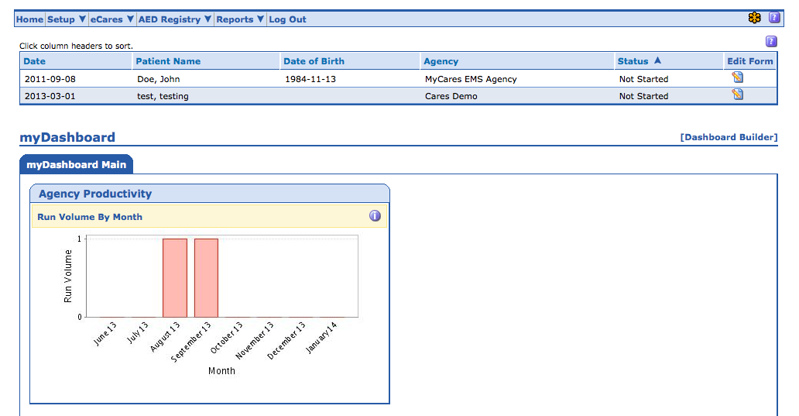

The five required hospital questions are: ER Outcome, Hospital hypothermia, Hospital outcome, Discharge from the hospital, and Neurological outcome at discharge. Please select the appropriate answers for these questions – coding examples can be found in the CARES Data Dictionary. Questions #51-55 are optional and should only be entered if you are interested in collecting this additional data. Feel free to enter notes in the Hospital Comments section to be reviewed by CARES staff (i.e. incorrect patient age, cardiac arrest etiology, etc.). After all questions have been answered, click Save.

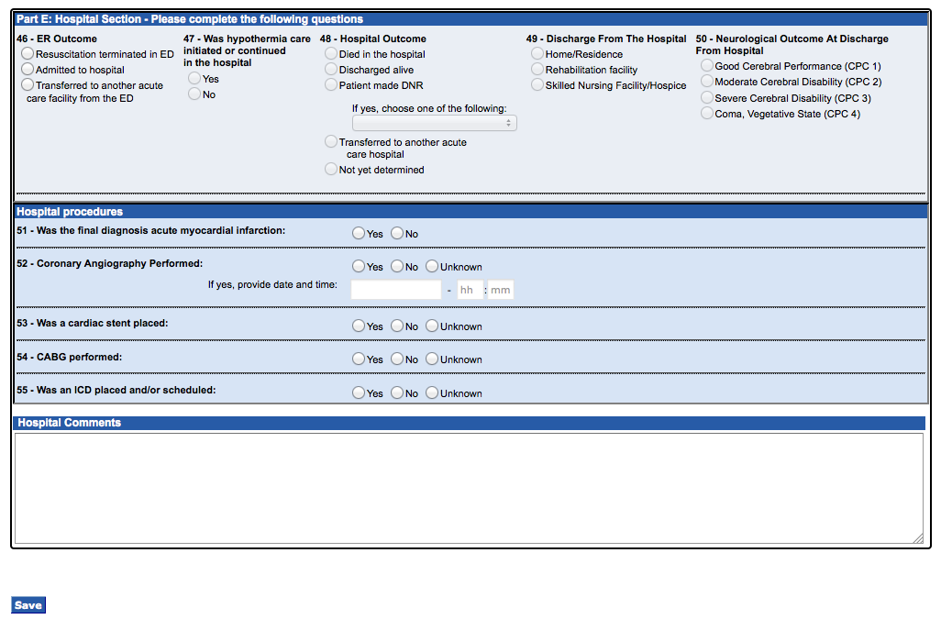

If notes were entered in the Hospital Comments box, the pop-up box below will generate.

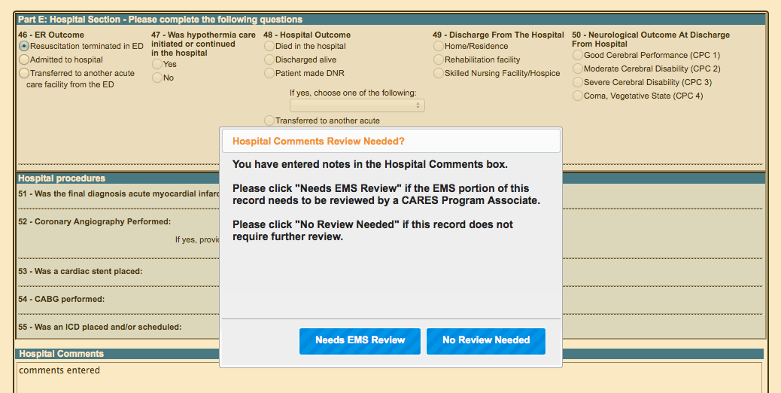Please click “**Needs EMS Review**” if the comments require review by CARES staff or EMS personnel (i.e. the EMS portion of the record needs possible correction, you are unable to locate the patient in your EMR, etc.) and “**No Review Needed**” if the comments were entered for internal purposes only and do not require review by CARES or EMS.

After you click Save, the hospital section will be audited by the CARES software. Any blank fields and/or potentially conflicting information will be flagged on the Save page. Please click the “**Return to the CARES Form**” link to correct the data or enter comments. Do NOT use your browser’s Back button to return to the form. The fields that require attention are listed at the top of the page and highlighted in red. Click “Save” when updates are completed in the form.

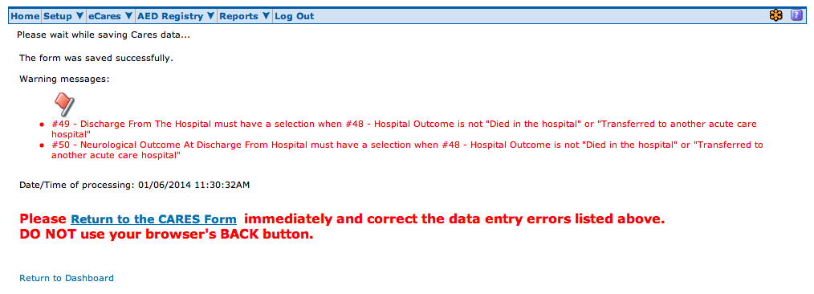

If there are no errors, click the “**Return to Dashboard**” link on the Save page.

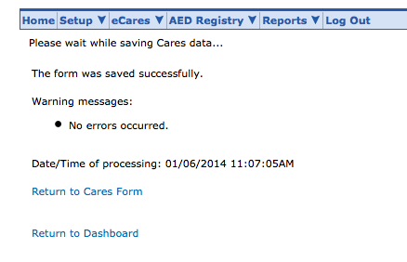

**PASSWORD CHANGE:**

You can change your CARES password by clicking the “**Password Change**” option on the “**Setup**” tab drop down menu.

If you’ve forgotten your CARES password, please click on the “**Forgot password**” link below the log-in box on the CARES homepage. You’ll be prompted to answer your unique password question, and a new password will be e-mailed to you.

**MULTI-HOSPITAL USERS:**

If a hospital user enters outcomes for multiple facilities, they can log in to CARES with a single username/password. Upon log-in, multi-hospital users will see a blank Dashboard. To enter data, select a hospital from the pull-down menu in the upper right-hand corner, click “Emulate”, and you’ll be taken to that respective hospital’s dashboard. When you click “Log Out” while emulating, you’ll be taken back to the main Dashboard.

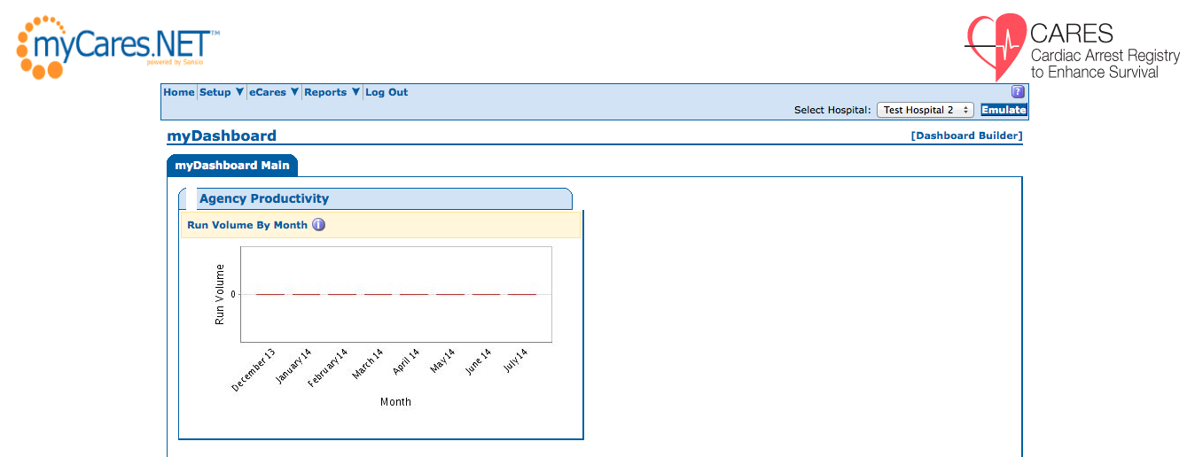

**DIFFICULTY LOCATING PATIENTS IN RECORD SYSTEM:**

If you are having difficulty locating a CARES patient in your hospital’s medical records system, below are some steps to try:

* Search by a similar name spelling, or the first few letters of the patient’s name only.
* Search without Date of Birth, as this could be miscoded by EMS personnel.
* Search by last name only.
* Search the Emergency Department log book by date and time of arrival at ED.
* Search by date of arrest and ICD code 427.5 (cardiac arrest).

If you are still unable to locate the patient, please enter a note in the Hospital Comments box and select “Needs EMS Review” in the pop-up box after clicking Save.

**CARES SEARCH AND EXPORT:**

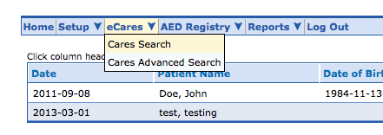

The **CARES Search** page is limited to the required elements, while the **CARES Advanced Search** page includes the supplemental elements as well. You can search by any EMS or Hospital data element(s) on the CARES form.

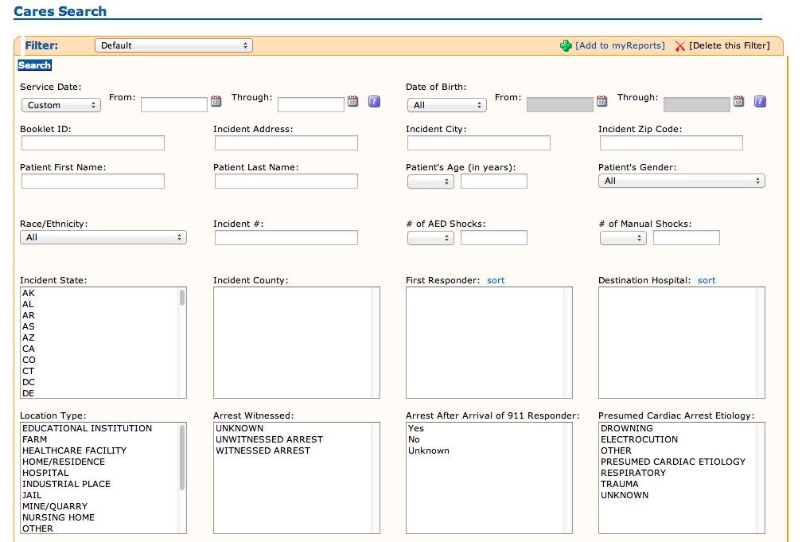

The search results can be exported into Microsoft Excel for further review and analysis. On the search results page, in the upper right-hand corner is a “Send results to” drop down menu. Click the drop down arrow and select “**Excel export of data**” or “**Excel export of data with optional elements**”. Click “Go”. Please be sure your browser’s pop-up blocker is turned off or hold down the “Ctrl” key while going through the above steps until the Excel window opens.

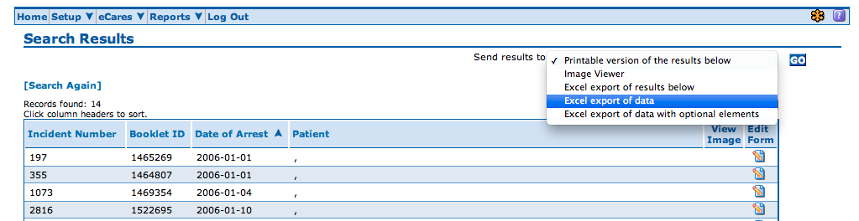

**HOSPITAL REPORT:**

The **CARES Hospital Report** includes both pre-hospital and in-hospital characteristics of a hospital’s respective OHCA patient population. The report allows hospital users to track their internal performance and compare against state and national benchmarks, where applicable. State data will be provided upon request through your CARES State Coordinator.

To generate the hospital report, access the “**Reports**” tab in your CARES account and click on “**Hospital Report**” in the drop down menu. To customize your report:

1. Select “Hospital Data” = Yes to view your hospital-specific data. Select “National Data” = Yes to add a national benchmarking column to the report.
2. Enter the Service Date range of interest. Reports using recent data are not completely audited and therefore may be incomplete. Data by calendar year is not finalized until April 1st of the following year. For example, reports including data from 2014 would not be considered final until April 1, 2015.
3. Select origin of patient (Direct from EMS, Transferred from Another Facility, or All).
4. Select Data Type (Presumed Cardiac CARES Cases OR Non-Traumatic CARES Cases).

Inclusion criteria are listed at the top of the report. Patients are included in the report of the *final* facility of care. Patients transferred out of your facility (from the ED or after hospital admission) and incomplete records are *not included* in this report.

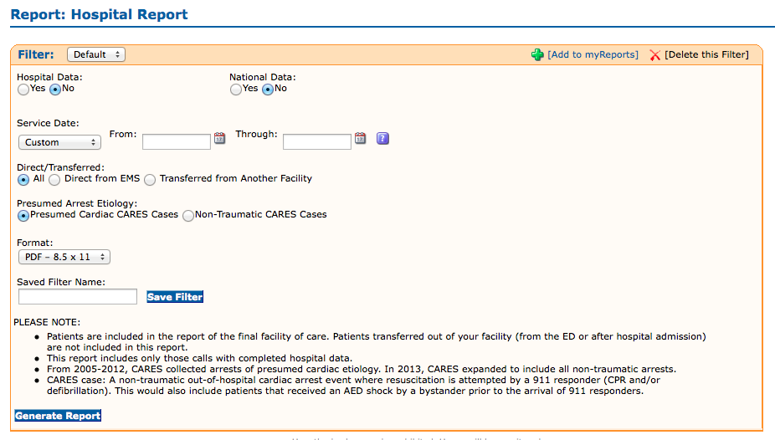

After clicking “Generate Report”, the pop-up box below will appear. This box reminds you that recent data may not be completely audited; data by calendar year is not finalized until April 1st of the following year. Click OK to acknowledge your understanding of this message.

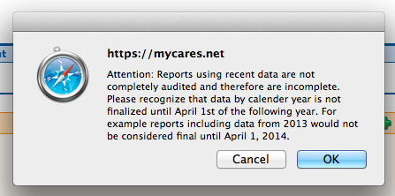

The top of the Hospital Report lists the total number of CARES patients received by your hospital during the date range of interest. The total is broken down by the number/percent who were transported directly by EMS and those who were transferred from another facility. Please note: the Hospital Report can be filtered by these criteria on the report setup page.

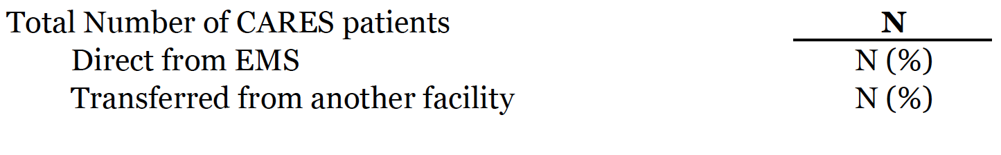

The Hospital Report summarizes the number and percentage of patients who survived to hospital admission and discharge, for each pre-hospital characteristic. “Survived to admission” includes patients for whom ER Outcome = admitted to ICU/CCU, admitted to floor, or admitted to hospital. “Survived to discharge” includes patients for whom Hospital Outcome = discharged alive or patient made DNR 🡪 discharged alive. The denominator for both survival rates is the N in the left-most column (Total).

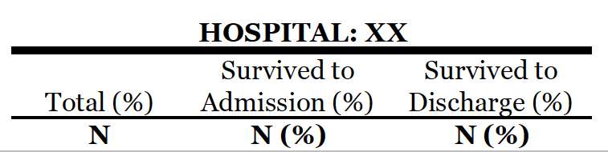

**Pre-Hospital Characteristic Definitions:**

**Initial Rhythm** – First cardiac rhythm present when a manual monitor/defibrillator or AED is attached to a patient.

Shockable: includes Ventricular Fibrillation, Ventricular Tachycardia, and Unknown Shockable rhythms

Unshockable: includes Asystole, Idioventricular/PEA, and Unknown Unshockable rhythms

**Witnessed Status** – A witnessed arrest is one that is seen or heard by another person.

**Sustained ROSC in field** – Return of Spontaneous Circulation (ROSC) is defined as the restoration of a palpable pulse or a measureable blood pressure. Sustained ROSC is deemed to have occurred when chest compressions are not required for 20 consecutive minutes and signs of circulation persist.

**Hypothermia care initiated in the field** - Hypothermia care is provided in the field if measures were taken to reduce the patient’s body temperature by means of external cold pack application to armpits and groin or administration of cold intravenous saline bolus, with or without sedation or other medications.

**Utstein patient** – Cardiac arrest was witnessed by a bystander and patient was found in a shockable rhythm.

**In-Hospital Characteristic Definitions:**

**Hypothermia care initiated/continued in hospital** - Hypothermia care is provided in the hospital if measures were taken to reduce the patient’s body temperature by either non-invasive means (administration of cold intravenous saline, external cold pack application to armpits and groin, use of a cooling blanket, torso vest or leg wrap devices) or by invasive means (use of a cooling catheter inserted in the femoral vein).

**Good Cerebral Performance** – Conscious, alert, able to work and lead a normal life.

**Moderate Cerebral Disability** – Conscious and able to function independently (dress, travel, prepare food), but may have hemiplegia, seizures, or permanent memory or mental changes.

**Supplemental Hospital Elements** – These data elements are OPTIONAL. The denominator for these metrics is the number of cases for whom these questions were answered. Blank fields and “unknown” responses are not included in the analysis.

**For further interpretation of this report, an online Hospital Report Webinar may be accessed at:** [**https://www.dropbox.com/s/4oarsnbjuc2aze1/Hospital%20Webinar.mp4.zip?dl=0**](https://www.dropbox.com/s/4oarsnbjuc2aze1/Hospital%20Webinar.mp4.zip?dl=0)**.** **MASS COMMUNICATION:**

Occasionally, CARES will send updates to our end users and stakeholders. These messages may include information about software upgrades and changes, training and education opportunities, or include documents such as our quarterly newsletter. You will receive these messages via e-mail, and they will also be accessible in your CARES Message Center upon log-in.

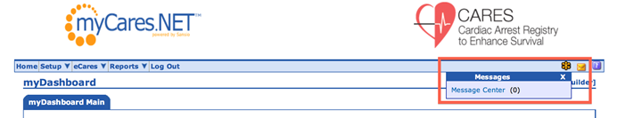Once you enter the site, a blinking, yellow envelope will indicate a new message in your inbox. You may access your Message Center at the top right-hand corner of the page.

High Priority messages will require your acknowledgment before navigating away from the page by checking the box and choosing “Save and Close”.

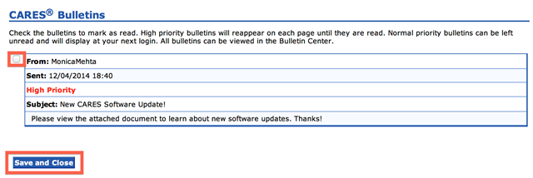

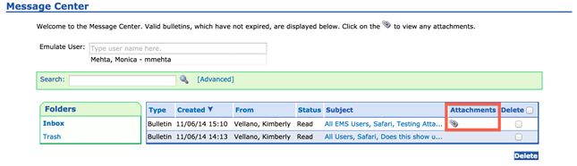You will be able to save any attachments that are included in the message for future reference by accessing your Message Center inbox and clicking on the paper clip icon under the “Attachments” column.

**TARGETED TEMPERATURE MANAGEMENT (TTM) MODULE GUIDE:**

Please contact your CARES representative to request that the TTM module be activated for your hospital. To enter data, log in to the CARES website with your unique username and password. The Targeted Temperature Management (TTM) Module has two potential silos of data, out-of-hospital cardiac arrests (patients transported to a hospital by CARES agencies) and in-hospital cardiac arrests.

Entering OHCA Data

The **Out-of-Hospital Cardiac Arrest (OHCA) TTM Module** form is accessed by clicking on the pen/paper icon for patients on your dashboard. The additional elements are located below the Hospital Comments box.

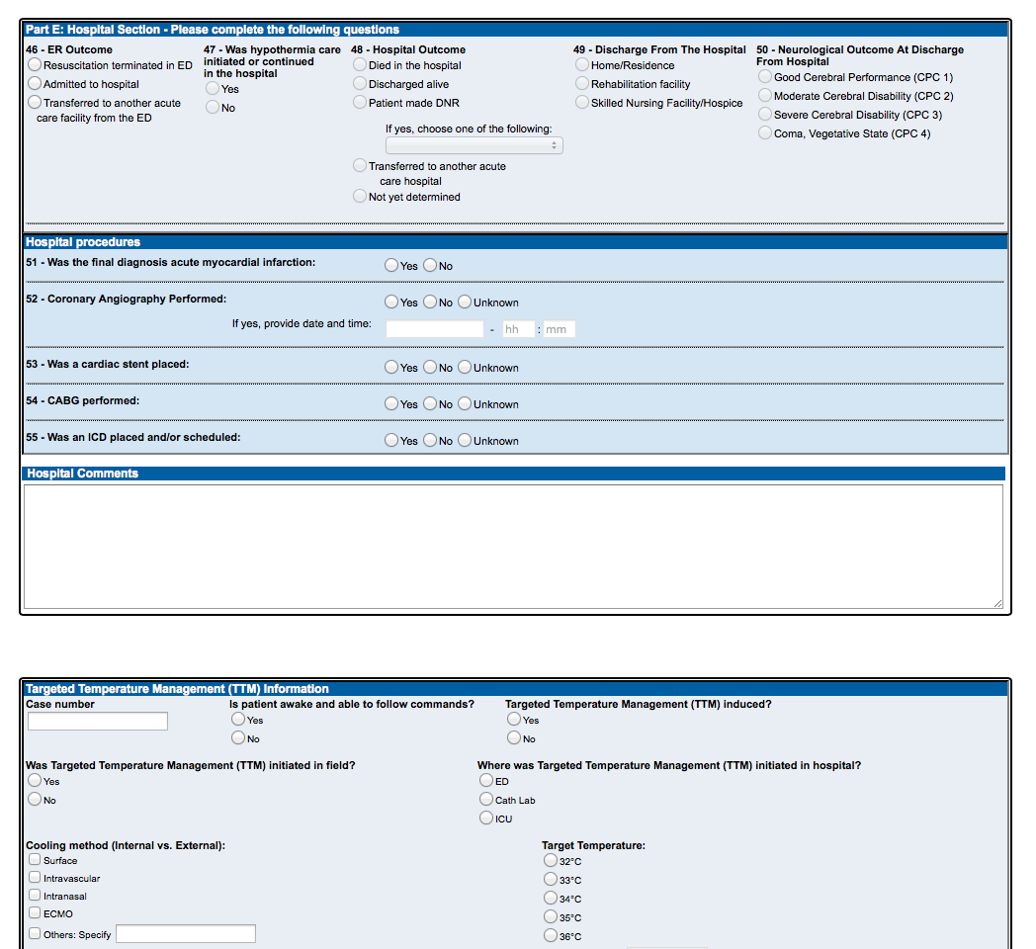

Please refer to the CARES TTM OHCA Data Dictionary for data definitions and coding examples. The form includes logic, which will grey out questions that are not applicable. After you’ve completed the form, click the Save button at the end of the Module section.

Entering IHCA Data

The **In-Hospital Cardiac Arrest (IHCA) TTM Module** form is accessed by clicking on the “Add New IHCA Case” link under the “TTM Module” tab.

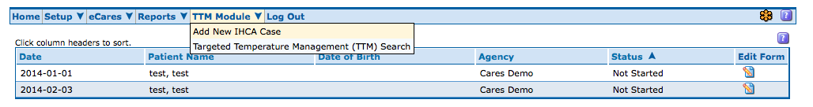

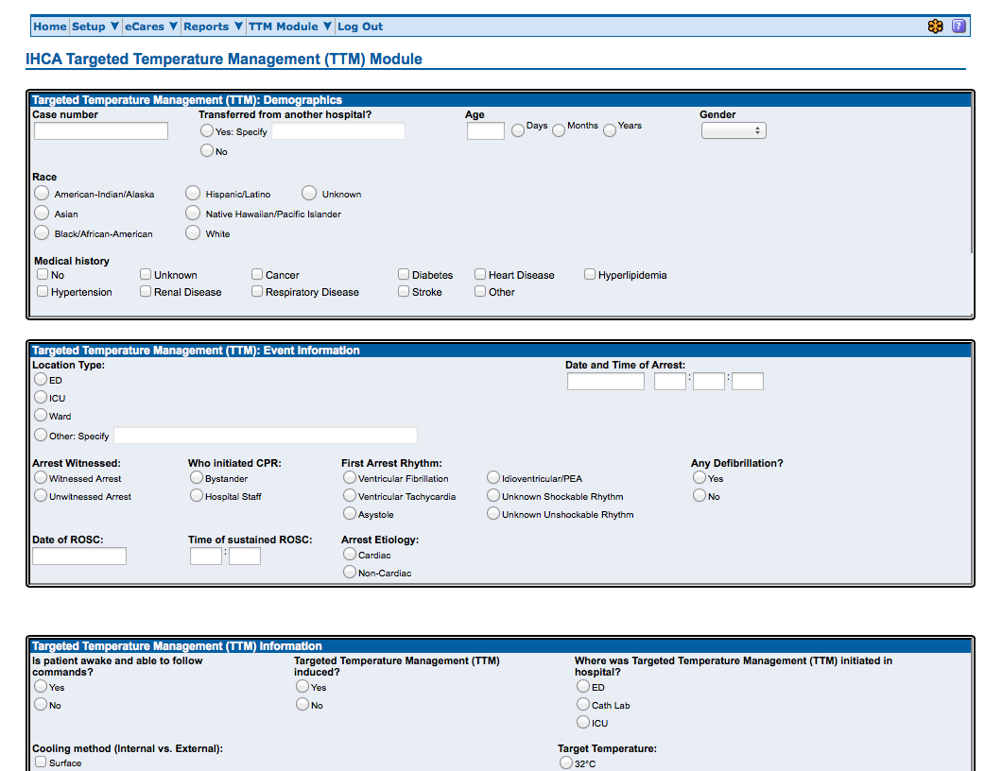

Please refer to the CARES TTM IHCA Data Dictionary for data definitions and coding examples. After you’ve completed the form, click the Save button at the bottom of the page.

Searching and Exporting Data

This module includes a search page, allowing users to locate records based on date of arrest, gender, age, and case number. The search page is found under the TTM Module tab.

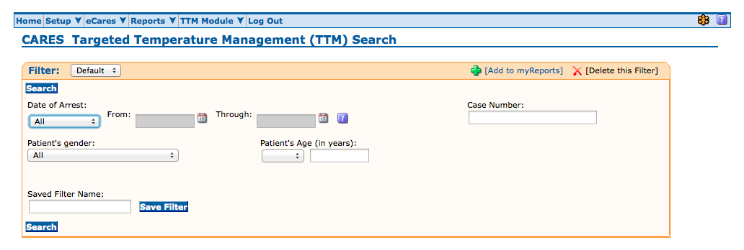

The first column of the search results indicates the type of arrest (OHCA or IHCA), while subsequent columns list case number, EMS Incident # (where applicable), and date of arrest. To re-open a record, click on the pen/paper icon.

TTM data is exportable into Microsoft Excel. Select “Excel export of TTM Data” from the “Send results to” pull-down menu and click Go. Please ensure that your browser’s pop-up blocker is off.

