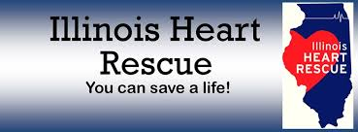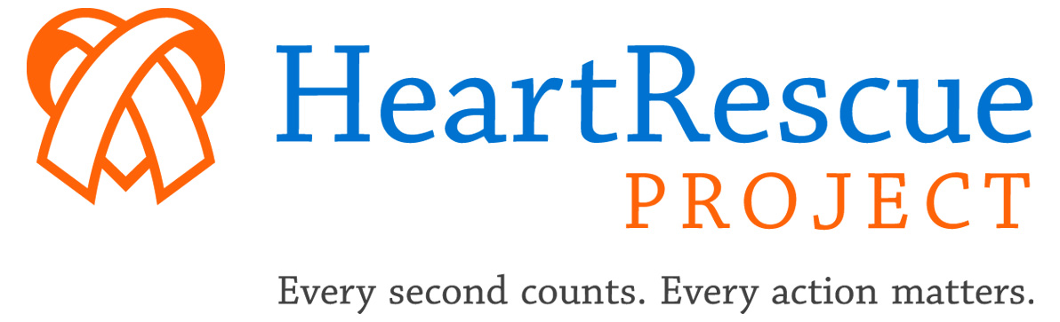

RESUSCITATION ACADEMY
WORKSHOP
THIS IS AN INTENSE 1 DAY WORKSHOP THAT WILL CONSIST OF SMALL GROUP DISCUSSIONS, LECTURES AND HANDS-ON EXCERCISES AND SCENARIOS
Three tracks focus on
Dispatch Assisted CPR
Dispatch assisted CPR can double the rate of Bystander CPR rates prior to the arrival of EMS. This track will dive into 2 key elements of Dispatch Assisted CPR (DA-CPR), training and quality improvement.
High Performance CPR
Performance not protocol make the difference in cardiac arrest survival. This dynamic hands-on track will focus on mastering the 10 points of HP-CPR, will teach how to choregraph HP CPR for any number of providers and assist in the creation of a QA/QI CPR improvement plan for your agency.
Therapeutic Hypothermia for pre-hospital / hospital
To cool or not to cool? Research has demonstrated that cooling dramatically improves neurologic outcomes for ROSC survivors. Recent publications have added to the confusion related to the efficacy of therapeutic hypothermia (TH). This module will discuss pre-hospital versus hospital cooling goals, challenges and techniques.
WHEN: TBD
TIME: 8:00 am – 3:30 pm (breakfast and lunch included)
WHERE: TBD
For more information on the next academy, contact:
Teri Campbell: tlc.ilhr@outlook.com (p) 312-720-0835

